**Recognition of Crop Diseases Based on Deep Learning**

**RESULTS**

**1. USER INTERFACE**

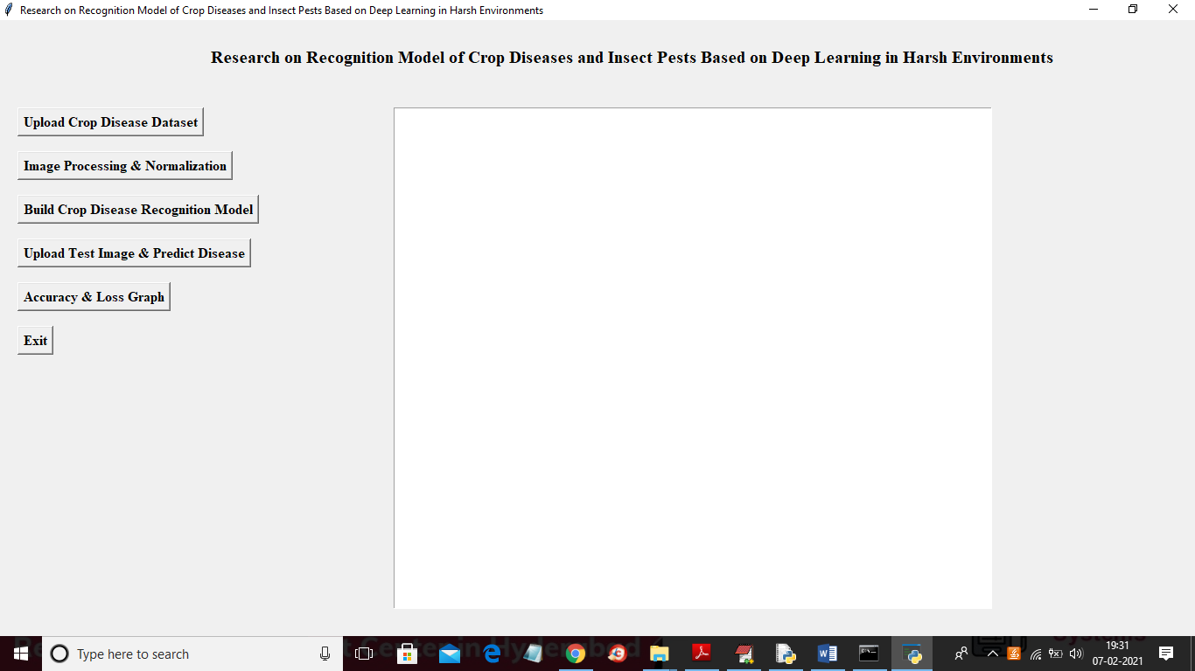

**2. UPLOAD DATASET**

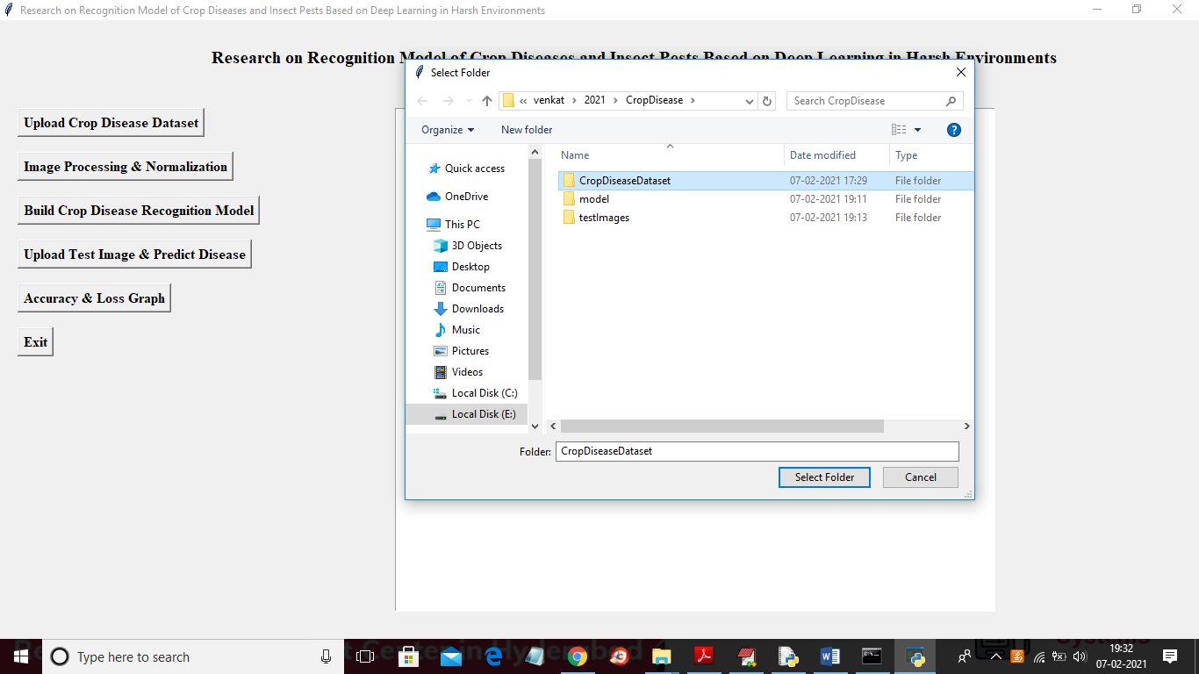

In the above screen select and upload the ‘CropDiseaseDataset’ folder and then click on the ‘SelectFolder’ button to load the dataset and to get below screen.

**3. CROP DISEASE DATASET**

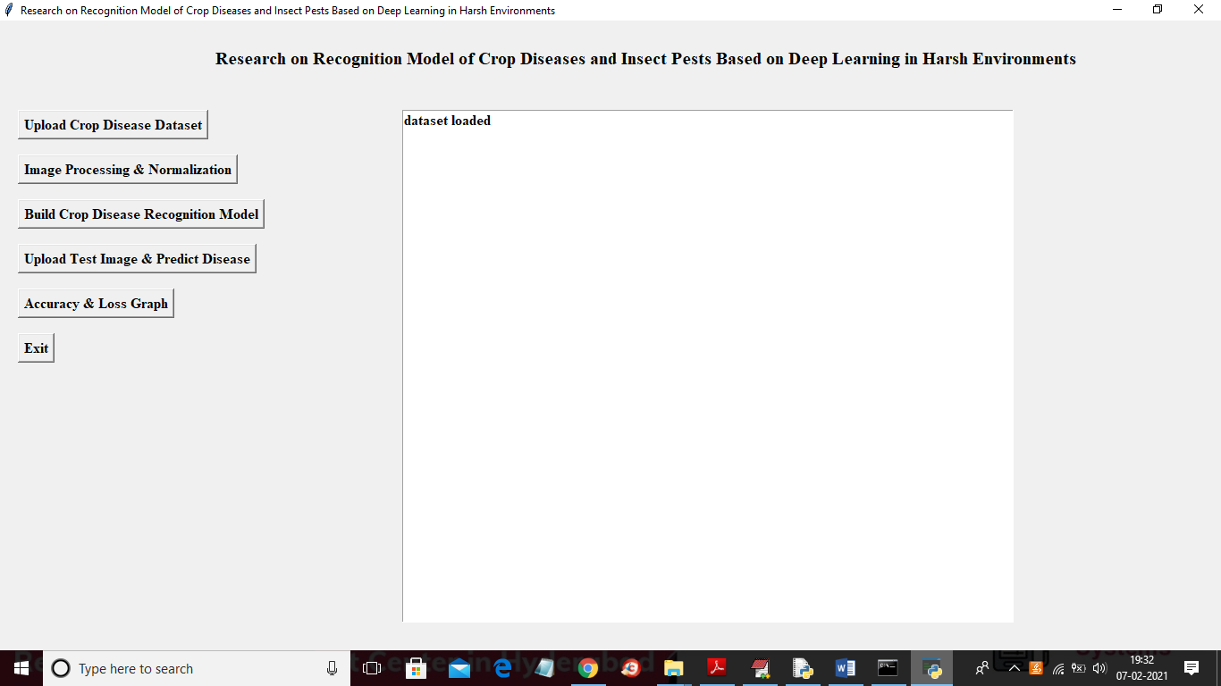

In the above screen dataset is loaded and now click on the ‘Image Processing & Normalization’ button to read all images.

**4. IMAGE PROCESSING & NORMALIZATION**

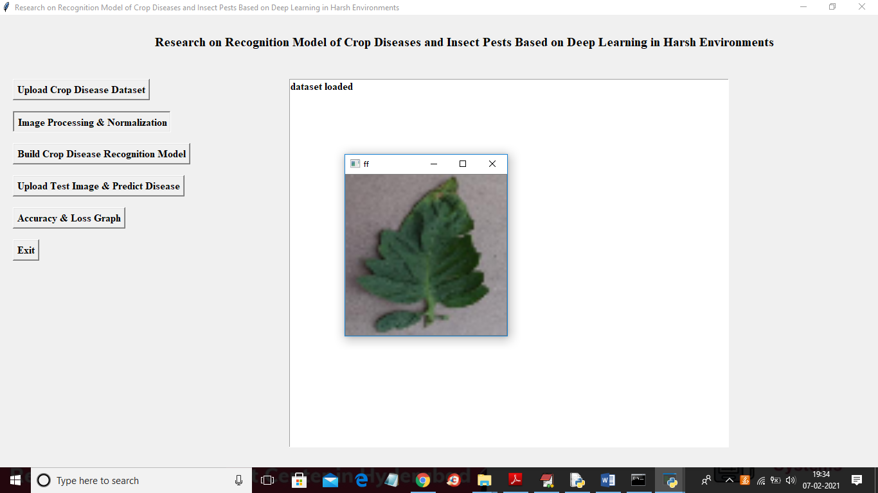

In the above screen after applying normalization we are just displaying one random image from the dataset to check whether images are loaded and processed properly or not and now you close the above image to get the below screen.

**5. IMAGE PROCESSING**

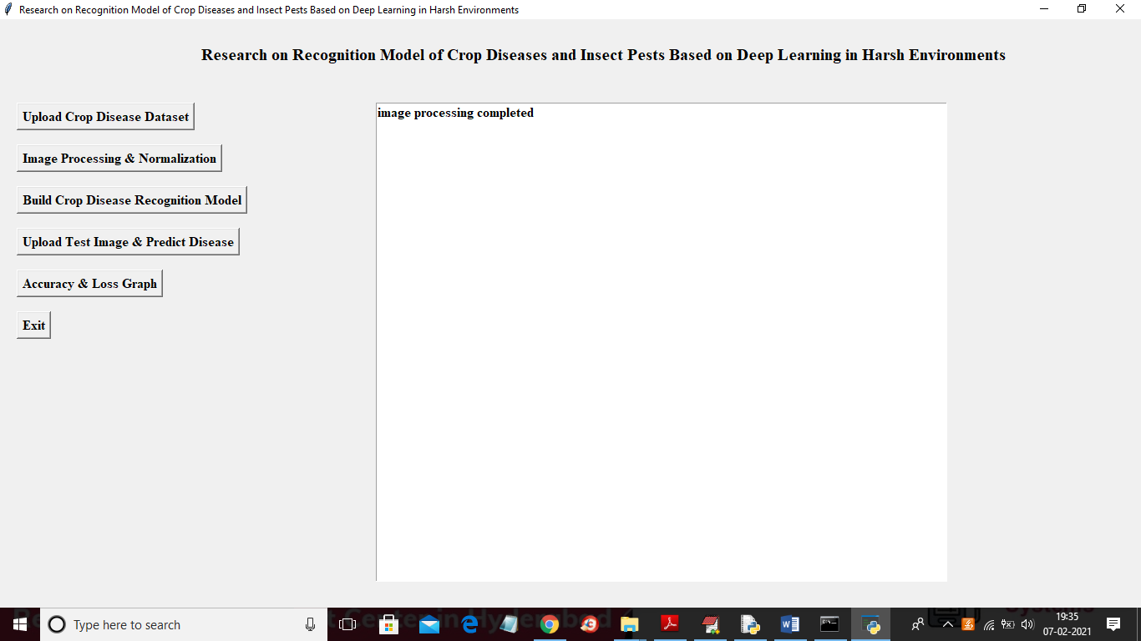

In the above screen, all images were processed successfully and now the dataset images are ready click on the ‘Build Crop Disease Recognition Model’ button to build the CNN model.

**6. BUILD CROP DISEASE RECOGNITION MODEL**

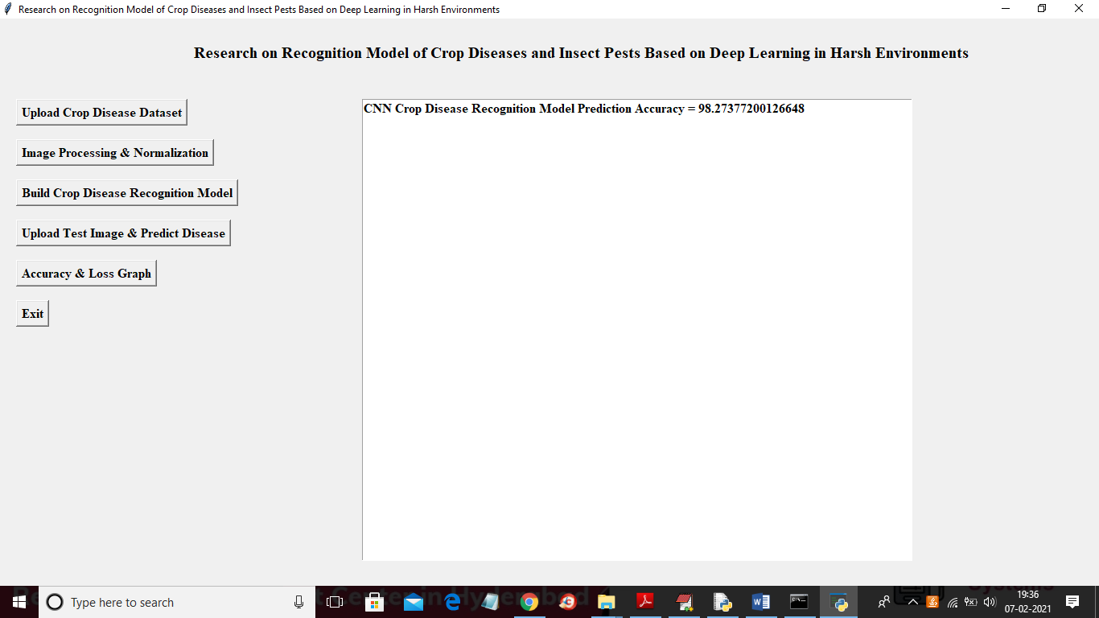

In the above screen, the CNN model is generated and its prediction accuracy is 98% in the below-console screen we can see all the CNN layer's details.

**7. CNN LAYER DETAILS**

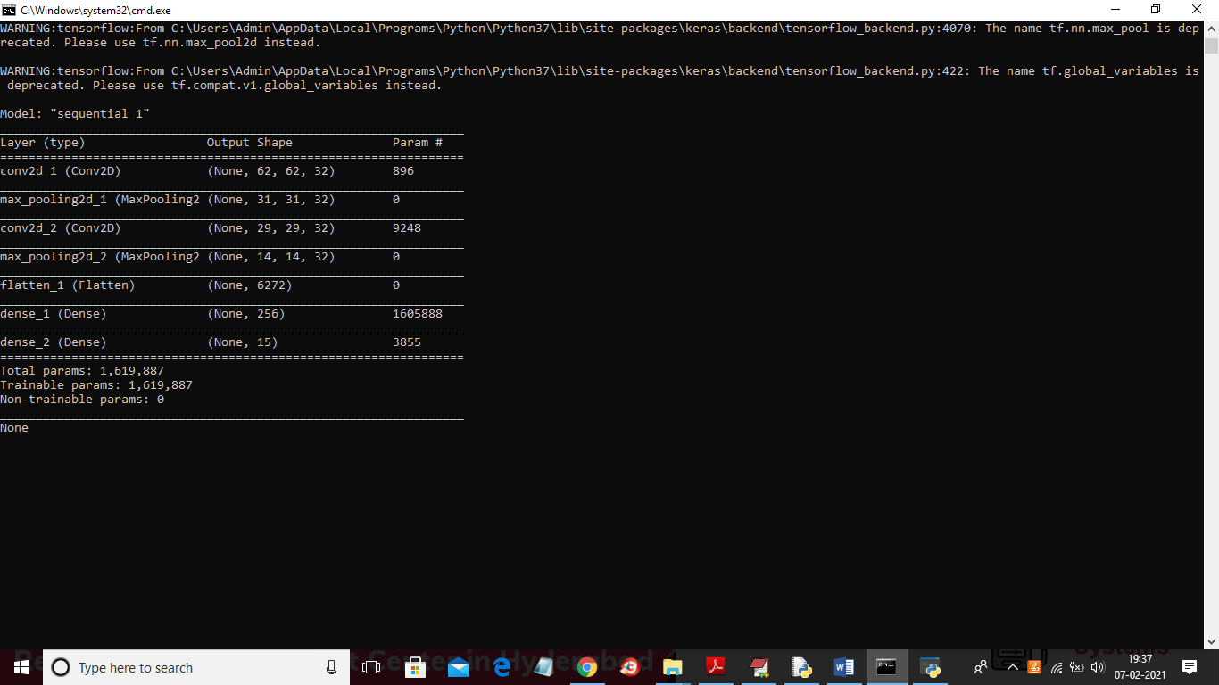

In the above screen, we can see we have used CONV2D, MAXPOOLING, FLATTEN, and DENSE layers to build the crop disease recognition model and RELU details you can see in the code. Now the model is ready and now click on the ‘Upload Test Image & Predict Disease’ button to upload any test image and then the application will predict disease or health from that image.

**8. PREDICT DISEASE**

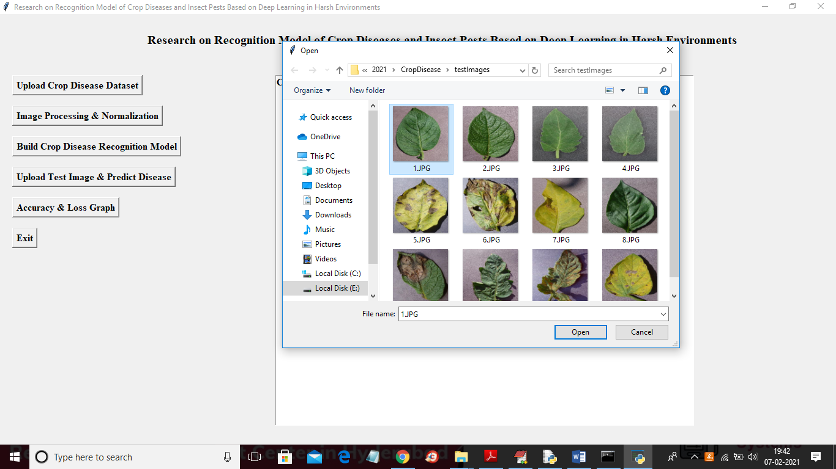

**WITHOUT DISEASE:**

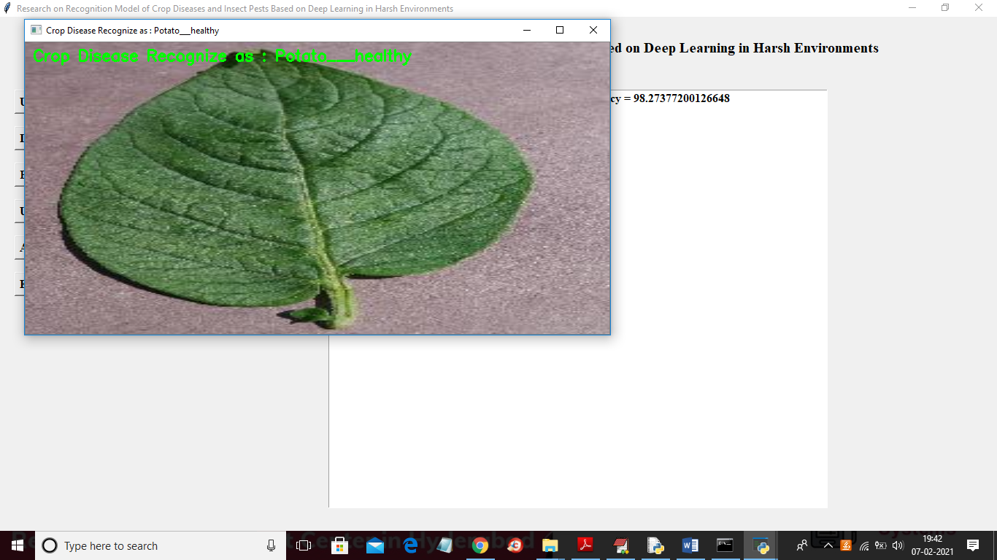

**WITH DISEASE:**

**INPUT:**

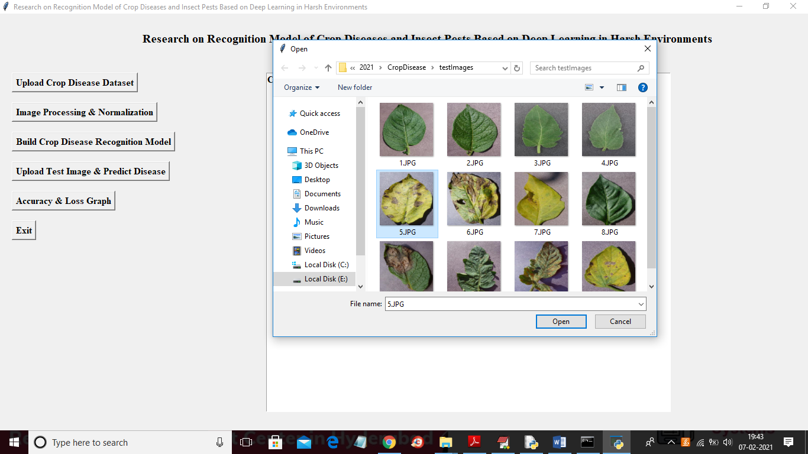

**OUTPUT:**

